What did they carry and Why?
In the Illustration Below, write down the character’s name, what they carried, and why.
Direct Quotes Will Help You Here!
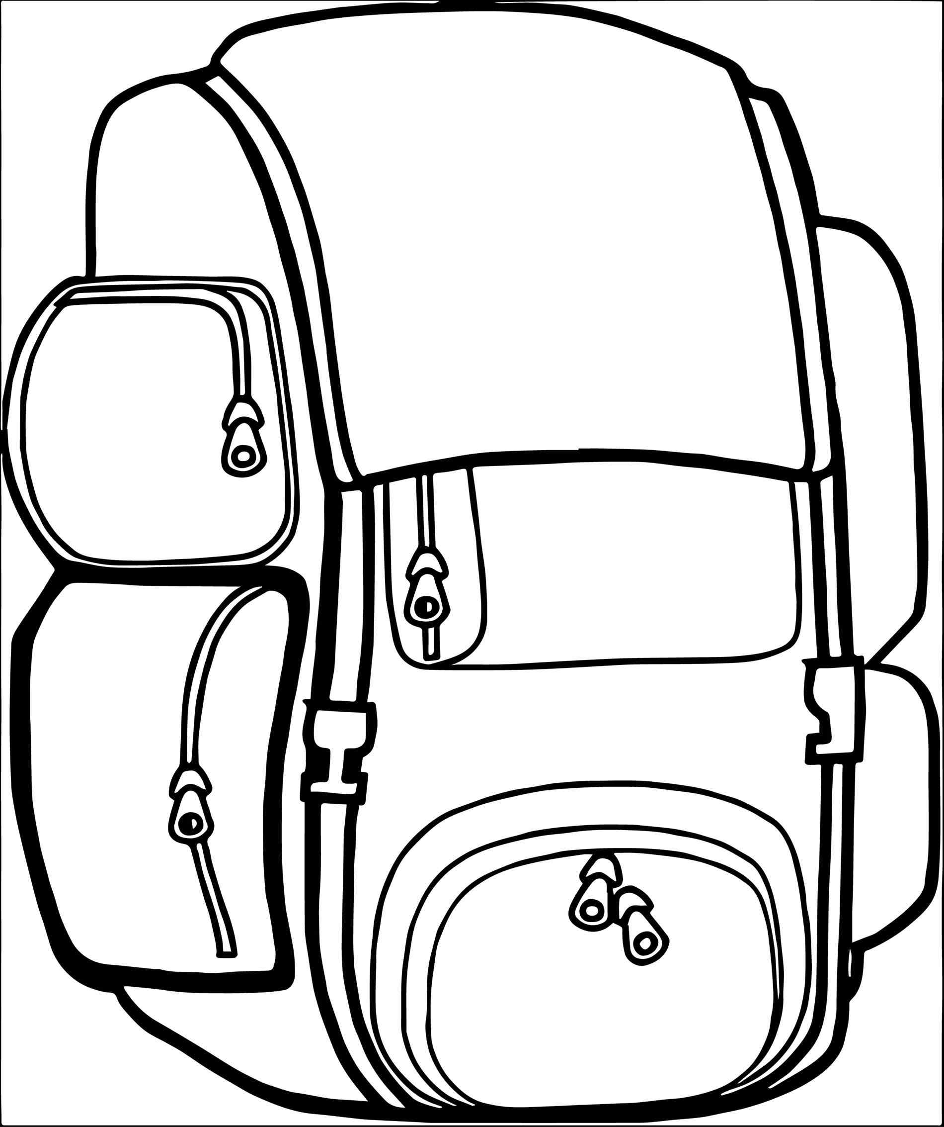
“THE THINGS THEY CARRIED”
Discussion Notes:

- Why does O’Brien write his first story, “The Things They Carried”, in third person? How does this serve to introduce the rest of the work?
- In the list of all the things the soldiers carried, what item was the most surprising? Which item did you find most evocative of the war? Which item/s stay with you?
- To what extent do the things they carried function as O’Brien indirect/direct characterization for each character?
  - What does the item reveal about them, their personalities, and their strengths/weaknesses?
- To what extent does the violence, the gritty description, and the vulgar language (O’Brien’s diction!) able to add depth and meaning to the story, rather than detract from it?
- Do the items that the soldiers carry serve as a talisman? Why or why not?

