Reformers Socratic Seminar “Rubric”

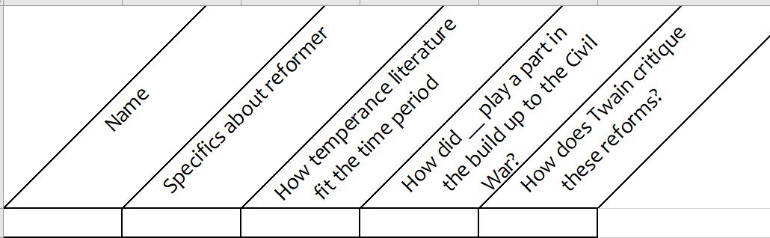

40 points available.
Remember, quality of response rather than quantity of times you talk.

