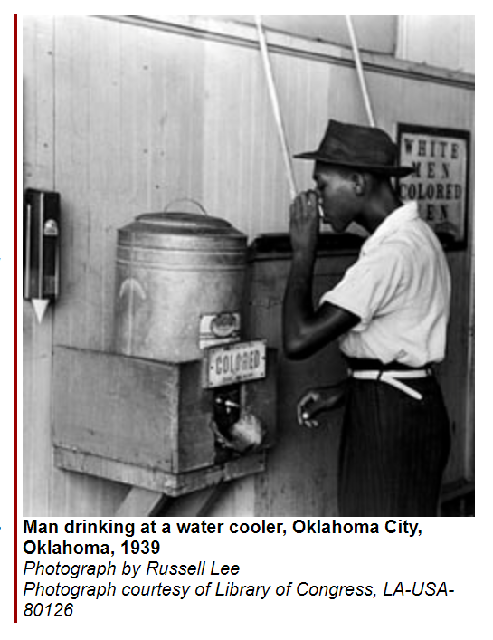
The white race deems itself to be the dominant race in this country...But in the view of the Constitution, in the eye of the law, there is in this country no superior, dominant ruling class of citizens...Our Constitution is color-blind... In respect of civil rights, all citizens are equal before the law... It is, therefore, to be regretted that this high tribunal... has reached the conclusion that it is competent for a State to regulate the enjoyment by citizens of their civil rights solely upon the basis of race...
We boast of the freedom enjoyed by our people above all other peoples. But it is difficult to reconcile that boast with a state of the law which, practically, puts the brand of servitude and degradation upon a large class of our fellow-citizens, our equals before the law. The thin disguise of "equal" accommodations...will not mislead anyone, nor atone for the wrong this day done.
Supreme Court Justice John Marshall Harlan, dissenting opinion in Plessy v. Ferguson, 1896 The "wrong this day done" to which Justice Harlan referred was the 1896 Supreme Court decision in Plessy v. Ferguson. Homer Adolph Plessy, an African American, had boarded a train in New Orleans and seated himself in a "whites-only" car. When he refused to move, he was arrested for violating the "Jim Crow Car Act of 1890." The incident led to the Supreme Court case in which all but Justice Harlan voted against Plessy, affirming the right of states to enact segregation laws. The "separate but equal" ruling set the stage for the rampant racial discrimination that followed in the Deep South. In many cities and towns, African Americans were not allowed to share a taxi with whites or enter a building through the same entrance. They had to drink from separate water fountains, use separate restrooms, attend separate schools, and even swear on separate Bibles and be buried in separate cemeteries. They were excluded from restaurants and public libraries. Many parks barred them with signs that read "Negroes and dogs not allowed." One municipal zoo went so far as to list separate visiting hours.
African Americans were expected to step aside to let a white person pass, and black men dared not look any white woman in the eye. Black men and women were addressed as "Tom" or "Jane" but rarely as "Mr." or "Miss" or "Mrs." A black man was referred to as "boy" and a black woman as "girl"; both often endured insulting labels of "nigger" or "colored."
Voting rights discrimination was widespread. In Tennessee, as the Justice Department's John Doar discovered on a self-appointed tour of rural Haywood County, black sharecroppers were being evicted by white farmers for trying to vote. In Mississippi, names of new voter applicants had to be published in local newspapers for two weeks before acceptance, and voters had the right to object to an applicant's "moral character." Black applicants, many of whom were illiterate or poorly educated, were also required to pass literacy tests and to interpret sections of the state constitution to the satisfaction of the registrars. These tests were not applied to illiterate whites. In Alabama, many registration centers were only open two days a month; voting registrars often arrived late and took long lunch hours. In 1957 the town of Tuskegee gerrymandered black residents outside the city limits to make them ineligible to vote. In nearby Macon County, voter registration boards used discriminatory practices such as these to limit the number of eligible black voters:
- ·holding black applicants to a higher standard of accuracy than whites;
- ·allowing white applicants to register in their cars and in their homes;
- ·processing black applicants last, even when they were first in line;
- ·establishing separate registration offices in different parts of the courthouse;
- ·offering assistance only to white applicants in completing the registration form;
- ·refusing to notify black applicants about the status of their applications.
Some counties in the Deep South resorted to harsher means of preventing local blacks from voting. They jailed black applicants and firebombed places where voter education classes had been conducted, such as Mt. Olive Baptist Church in Terrell County, Georgia. They threatened, beat, and in some cases, murdered black applicants.
Southern blacks who resisted segregation, particularly those in rural areas, lived in constant fear--fear of their employers, who vowed to fire them; fear of white "citizens' councils," who adopted policies of economic reprisal against demonstrators; and fear of white vigilante groups like the Ku Klux Klan, who exerted an often-unchecked reign of terror across the South, where lynching of African Americans was a common occurrence and rarely prosecuted. Nearly 4,500 African Americans were lynched in the United States between 1882 and the early 1950s.
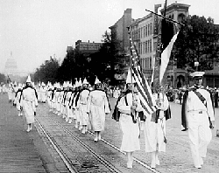

The KKK on Parade in Washington, DC, 1928
Photograph courtesy of National Archives and Records Administration, NWDNS-306-NT-650-4

Jim Crow in the 1940s
Growing up in central Pennsylvania in the late thirties and forties, I remember a popular movie was not showing in my hometown of Bellefonte. We had just two theatres, but the movie was showing at State College, home of the great Penn State Nittany Lions. But negroes could attend only if they sat in a special section in the balcony. I often wondered how Jim Crow traveled over the many Nittany Mountains to State College, Pennsylvania.
I settled, very hurt, for a weak Gene Autry western.
Another slap-in-the-face was the local branch of the American Legion. Of course at age of 17 I was not eligible, due to no record of service in the military. But their policy was "no colored", so because of this I went into the Navy in World War II, where I got
another dose of Jim Crow. The officers presumed us colored sailors to be suited to be cooks, waiters and house boys, with no regard to our background, education or aptitude. Imagine being segregated in civilian life and then have your government assign you to segregated units. To further humiliate us, we were assigned to separate sleeping bunks aboard the carrier.
This was not Mississippi in the 1920s. This was the 1940s. After the Navy, I joined the Washington Police Department. I could not drive any police vehicles in the nation's capital. When I was assigned on weekends, I could not arrest white people west of 7th St., I could only arrest whites when the white officers were off and we were needed to fill in.
Jim Crow was America's form of apartheid and the scars are still there.
James Stewart
Columbia, MD

