IB 12 Language & Literature
Language of Drama Analysis

Act: A major division in a play. An act can be sub-divided into scenes. Greek plays were not divided into acts. The five act structure was originally introduced in Roman times and became the convention in Shakespeare’s period. In the 19th century this was reduced to four acts and 20th century drama tends to favor three acts
Aside: Words spoken by an actor directly to the audience, but not "heard" by the other characters on stage during a play. Example: In Shakespeare's Othello, Iago voices his inner thoughts a number of times as "asides" for the audience.
Catharsis: The purging of the feelings of pity and fear. According to Aristotle the audience should experiences catharsis at the end of a tragedy
Comic Relief: Comic relief does not relate to the genre of comedy. Comic relief serves a specific purpose: it gives the spectator a moment of “relief ” with a light-hearted scene, after a succession of intensely tragic dramatic moments. Typically these scenes parallel the tragic action that they interrupt. Comic relief is lacking in Greek tragedy, but occurs regularly in Shakespeare's tragedies.
Example: The opening scene of Act V of Hamlet, in which a gravedigger banters with Hamlet.
Denouement / Resolution: Literally the action of untying. A denouement (or resolution) is the final outcome of the main complication in a play. Usually the denouement occurs AFTER the climax (the turning point or "crisis"). It is sometimes referred to as the explanation or outcome of a drama that reveals all the secrets and misunderstandings connected to the plot. (See Appendix 1: Freytag’s Pyramid)
Example: In Shakespeare’s Othello, the climax occurs when Othello kills his wife. The denouement occurs when Emilia, proves to Othello that his wife was in fact honest, true, and faithful to him.
Dialogue: The conversation of characters in a literary work. In plays, characters' speech is preceded by their names. (See Appendix 2 for discussion on what is dialogue in dramatic terms.) Diction: According to the Cambridge Dictionary, diction is “the manner in which words are pronounced.” Diction, however, is more than that: it is a style of speaking. In drama diction can (1) reveal character, (2) imply attitudes, (3) convey action, (4) identify themes, and (5) suggest values. We can speak of the diction particular to a character.
Example: Iago's and Desdemona's very different ways of speaking in Othello
Dynamic Character: Undergoes an important change in the course of the play- not changes in circumstances, but changes in some sense within the character in question -- changes in insight or understanding or changes in commitment, or values. The opposite is a static character who remains essentially the same.
Exposition: “The first stage of a fictional or dramatic plot, in which necessary background information is provided”. (See Appendix 1: Freytag’s Pyramid). In most drama the characters have to expose the background to the action indirectly while talking in the most natural way. What any person says must be consistent with his character and what he knows generally. Exposition frequently employs devices such as gestures, glances, “asides” etc.
Example: Ibsen's A Doll's House, begins with a conversation between the two central characters. This dialogue gives the audience details (in the most natural way) of what has occurred before the play began, details, of importance to the development of the plot. Falling Action: This is when the events and complications begin to resolve themselves and tension is released. We learn whether the conflict has or been resolved or not.
Flat Characters: Flat characters in a play are often, but not always, relatively simple minor characters. They tend to be presented though particular and limited traits; hence they become stereotypes.
For example, the selfish son, the pure woman, the lazy child, the dumb blonde, etc. These characters do not change in the course of a play.
Foil: A secondary character whose situation often parallels that of the main character while his behavior or response or character contrasts with that of the main character, throwing light on that particular character’s specific temperament.
Examples: In Hamlet, Laertes’, father is murdered. His situation parallels Hamlet’s situation but his response is very different. In Othello, Emilia and Bianca are foils for Desdemona.
Gesture: The physical movement of a character during a play. Gesture is used to reveal character, and may include facial expressions as well as movements of other parts of an actor's body.
Example: Most modern playwrights explicitly mention both bodily and facial gestures, providing detailed instructions in the play's stage directions.
Hubris: The Greek term hubris is difficult to translate directly into English. This negative term implies both arrogant, excessive self-pride or self-confidence, and a lack of some important perception or insight due to pride in one's abilities. This overwhelming pride inevitably leads to a downfall. (Taken from http://web.cn.edu)
Example: In Sophocles Oedipus, Oedipus’ refusal to listen to anyone illustrates hubris. He believes he knows best – even better than the prophet Tiresias – and his refusal to listen leads to his downfall.
Inciting Incident: The first incident leading to the rising action of the play. Sometimes the inciting incident is an event that occurred somewhere in the character’s past and is revealed to the audience through exposition.
Monologue: A speech by a single character without another character's response. The character however, is speaking to someone else or even a group of people. (see soliloquy below)
Examples: Shakespeare’s plays abound with characters talking with no one responding. A clear example of how a monologue addresses someone occurs when Henry V delivers his speech to the English camp in the Saint Crispin's Day speech. He wants to inspire the soldiers to fight even though they are outnumbered. This is a monologue because (a) he alone speaks (b) he is addressing other characters.
Motivation: The thought(s) or desire(s) that drives a character to actively pursue a want or need. This want or need is called the objective . A character generally has an overall objective or longterm goal in a drama but may change his or her objective, and hence motivation, from scene to scene when confronted with various obstacles.
Example: In the play Othello, Iago’s objective is Othello’s downfall.
Point of attack: The point in the story at which the playwright chooses to start dramatizing the action; the first thing the audience will see or hear as the play begins.
Reversal or Peripeteia: The point at which the action of the plot turns in an unexpected direction for the protagonist- from failure to success or success to failure.
Round Characters: A round character is depicted with such psychological depth and detail that he or she seems like a "real" person. The round character contrasts with the flat character who serves a specific or minor literary function in a text, and who may be a stock character or simplified stereotype. If the round character changes or evolves over the course of a narrative or appears to have the capacity for such change, the character is also dynamic. In longer plays, there may be several round characters.
Soliloquy: A speech meant to be heard by the audience but not by other characters on the stage (as opposed to a monologue which addresses someone who does not respond). In a soliloquy only the audience can hear the private thoughts of the characters.
Example: Hamlet's famous "To be or not to be" speech.
Static Character: A dramatic character who does not change. Suspension of Disbelief: Samuel Taylor Coleridge first used the term in 1817. In its most basic form the term means that we accept something as real or representing the real when it obviously is not. In drama this is a crucial condition, as we must put aside put aside our disbelief and accept the premise presented as real for the duration of the performance.
Stock Character: A recognizable character type found in many plays. Comedies have traditionally relied on such stock characters as the miserly father, the beautiful but naïve girl, the trickster servant.
Subplot: A subsidiary or subordinate or parallel plot that coexists with the main plot.
Example: The story of Rosencrantz and Guildenstern forms a subplot within the overall plot of Hamlet.
Tragedy: A type of drama in which the characters experience reversal of fortune, usually for the worse. In tragedy, suffering awaits many of the characters, especially the hero.
Tragic flaw: A weakness or limitation of character, resulting in the fall of the tragic hero.
Example: Othello's jealousy and too trusting nature is his tragic flaw. Tragic hero: A privileged, exalted character of high repute, who, by virtue of a tragic flaw and/or fate, suffers a fall from a higher station in life into suffering. Example: Sophocles' Oedipus.

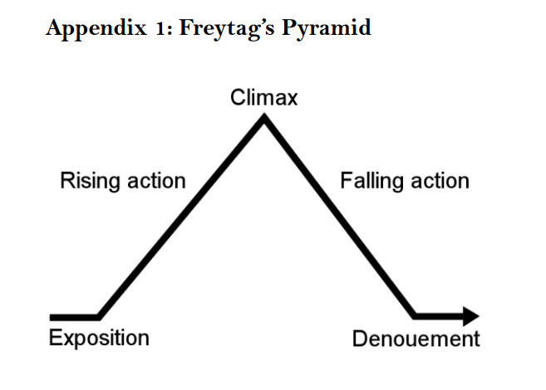
http://www.oranim.ac.il/sites/heb/SiteCollectionImages/pictures/english/expression/Glossary_of__drama_Dramatic.pdf

