Name:
“On the Rainy River”
Discuss the following (1-7) and note your group’s response.
- Juxtaposition
  - Long and short paragraphs
  - Love Story vs. War Story
- Discuss POV: 20-year reflective point of view
- What historical allusions/references does O’Brien make at the beginning of the chapter?
- Why include such detail in his job at the meat packing plant?
- In “On the Rainy River”, we learn the 21-year-old O’Brien’s theory of courage: “Courage, I seem to think, comes to us in finite quantities, like an inheritance, and by being frugal and stashing it away and letting it earn interest, we steadily increase our moral capital in preparation for that day when the account must be drawn down. It was a comforting theory.” What might the 43-year-old O’Brien’s theory of courage be?
- Where you surprised when he described his entry into the Vietnam War as an act of cowardice? Why? Why not? Do you agree that this decision was cowardice?
- What is the role of shame in the lives of these soldiers? Does it drive them to acts of heroism, or stupidity? Or both? What is the relationship between shame and courage according to O’Brien?

- (Independently) Fill out “your” Draft Card Registration:

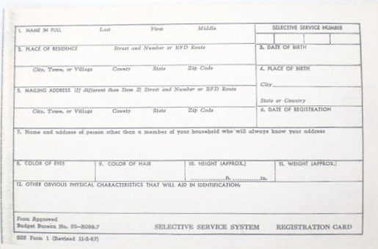

- (Independently) Explore the ideas of Courage, Coping, and The Nature of Memory both in the stories, and if applicable, your own life in a “free write” in your green packet.

