The new unit, beginning Thursday, will have a couple of options to create accountability for the reading. One option is to submit a Quick Write (prompts provided) to Turnitin.com on the assigned day. Or, if you choose, you can join a Zoom meeting with Ms. Boas for a quick meeting to discuss “deep thoughts”
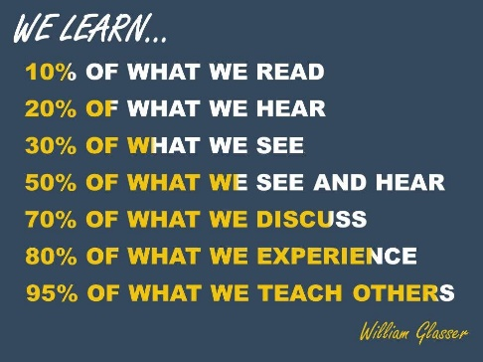

I thought this image was interesting as we finish our Distance Learning. Once again, if you’re able, may I encourage you to be part of our quick discussions at the end of each reading section

As always, please see the Website for Meeting Times and links to important documents.

Here is what our last three full weeks will look like for English – I can’t believe it’s June already!
Monday | Tuesday | Wednesday | Thursday | Friday
1  Finish Fences | 2  Socratic Seminar Day 1 (links provided in morning email) | 3  Socratic Seminar Day 2 (links provided in morning email) | 4  Introduction to The Things They Carried Meeting | 5  Read:  “The Things They Carried”  Make-up Soc Sem
8  Finish Reading “The Things They Carried”  -----------------------------------  Quick Write or Mtg. w/Boas | 9  Read:  “On the Rainy River” | 10  Finish Reading  “On the Rainy River”  -----------------------------------  Quick Write or Mtg. w/Boas | 11  Read:  “Sweetheart of the Song Tra Bong” | 12  HAPPY GRADUATION CLASS OF 2020!  --------------------------------  Finish reading “Sweetheart…”
15  Read:  “The Man I Killed”, “Ambush”, AND “Style” | 16  Finish Reading Monday’s & Friday’s Vignettes  -----------------------------------  Quick Write or Mtg. w/Boas | 17  Read:  “Speaking of Courage” OR “In the Field” | 18  Finish Reading Wednesday’s Vignette  -----------------------------------  Quick Write or Mtg. w/Boas | 19  The Things They Carried Culminating Activity
22  Time Capsule | 23  Last Day!

