Nisei Daughter
Notes and Reading Questions

Major Characters | Characteristics/Notes  (*continue filling out as you read the book)
Mr. and Mrs. Itoi
Monica “Kazuko” Sone
Henry (older brother)
Kenji (youngest brother)
Sumiko (sister)

Important Terms:

Directions: Match the following terms with their definition. Write the definition on the corresponding lines.

Sei =
Third Generation
First Generation
Prefectural Associations
Generation
Third Generation

Issei =

Nisei =

Sansei =

Kenjinkai =
- Local entities
- Governmental bodies of _______________ which are larger than cities, towns, and villages

- Monica’s parents are
- Monica and her siblings are

Issei | Nisei
- Men and women were mostly  __________________ years old when immigrating to America. | - Born in America, granted citizenship as _____________ right.
- ____________________ for US citizenship (permanent alien status) | - They were Americans, spoke ___________  - Idealized American ________________  - Went to American _______________
- Obeyed the custom “of the __________ structure of Japanese society, the tendency to grant special rights, privileges, and ____________ to those in higher status” (x) | - Isolated from ____________ ________________ society still, and also had limited participation in Japanese culture because they didn’t speak language fluently or understand traditions.
 | - “A Nisei was American, but not truly part of American society. A Nisei was certainly not Japanese, but Japanese influences seeped into aspects of his character and behavior” (xi-xii)

Historical Context:

Immigration Act of 1924:
Immigration and Nationality Act of 1952
HR 442 and SB 1009
Skid Row
Japanese Association
“The outbreak of war between Japan and the United States, and the evacuation of the Japanese minority, drastically changed the status of the Nisei” | “ ____________________”
Ten Internment/Concentration Camps

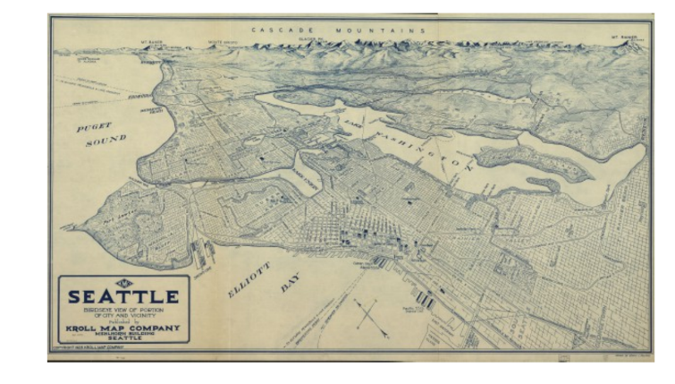

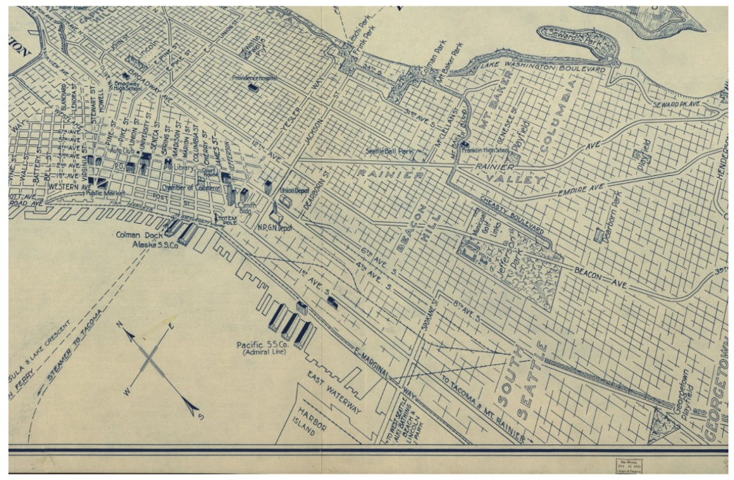

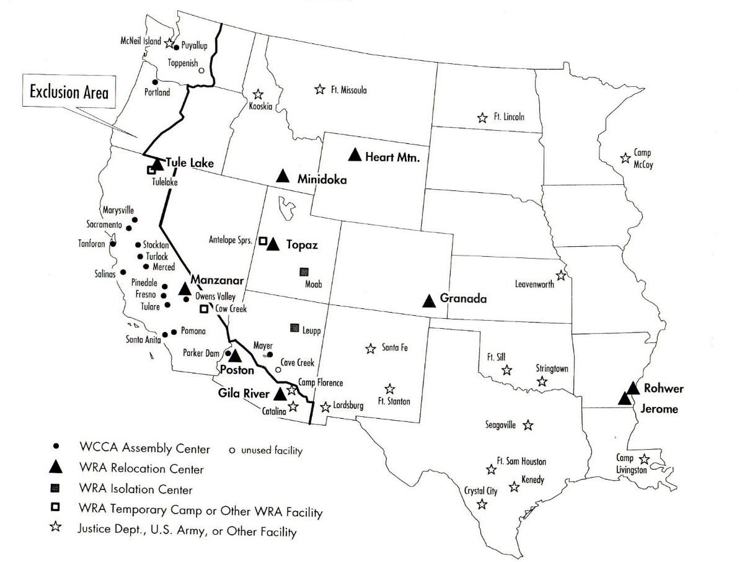

Map of War Relocation Authority Centers for detained Japanese Americans.

Reading Comprehension Questions
Please use the reading questions as an optional check of your reading comprehension.

Chapter 1
- Explain, “when I was a happy six-year-old, I made the shocking discovery that I had Japanese blood. I was Japanese” (3). Conclude how she feels about being Japanese (18-19)?
- What was Father’s dream when he moved to America? What was his reality?
- What was Mother’s entry into America like? Describe their road to marriage.
- Explain the family life in the early days in Seattle.
- How does Monica describe her childhood in the hotel?
- Describe Skid Row and all its inhabitants.
Chapter 2
- Describe Monica’s reaction to going to Japanese school. Conclude why you think she has that reaction.
- Examine Mr. Ohashi, his role in the novel, and his purpose in life. What are his goals for Japanese living in America?
- According to Mrs. Matsui, why are Mother and Father bad parents?
- Determine the impact the people on Skid Row have on the children.
- Conclude why Monica would say, “during those impressionable years, the police became our sworn enemies…” (34). Explain the situation with Father and the police. Examine the character Mr. Kato.
Chapter 3
- Why was Father so opposed to Monica taking dance lessons? What compromise do they reach? How does she feel about the compromise?
- Determine how Mother does not conform to the ‘proper ways’ of Japanese culture.
- What Japanese and American cultural values are presented in this chapter?
- Explain the incident at the Mickey Mouse party.

Chapter 5
- Determine how the kids and family feel like outsiders (or “an alien among them” 108) on their trip to Japan.
- Explain the incident with Cousin Yoshiye.
- How does Japan compare to their life in America?
- Determine how gender roles differ in America and Japan.
- How does their trip to Japan end? Explain some of the events.
- Determine why Ojih-chan (grandfather) does not move to America with the family.
- Investigate Monica’s final reflections on her trip to Japan.
Chapter 6
- When the family goes to the sea, why will nobody rent them a house?
- Why were Mother and Father not allowed to become “naturalized American citizens”? (113)
- Detail Mother’s reaction to the house rentals, and what advice she gives Monica.
- Examine Monica’s statement: “terrible curse that went with having Japanese blood” (118).
- Analyze the significance of: “Here we were born; here we wanted to live. We had tasted of its freedom and learned of its brave hopes for democracy. It was too late, much too late for us to turn back” (124).
Chapter 7
- Who is Haruo, and what role does he play in Monica’s life? Why must she keep this a secret from her parents?
- Examine why Monica struggles in high school.
- What is Monica’s plan for her future, and what is her reality?
- Define “picture marriage” and how Mother feels about this type of marriage (135).
- Why does Monica ‘enroll’ in North Pines Sanitarium, and what lessons about herself and society does she learn during her time?

Chapter 8
- How does Monica react to the news of the attack on Pearl Harbor by Japan?
- How does Chris (Monica’s friend) react to the bombing/attack?
- Discuss the divide in the family caused by the attack on Pearl Harbor.
- Explain the reaction of the US government in regards to Japanese Americans.
- What advice does Mrs. Matsui give Mother?
- Analyze the language of the following quote: “A Jap’s a Jap…You can’t make an American out of little Jap Junior by handing him an American birth certificate” (158).
- After all the racism and mistreatment, how does Monica feel about Seattle?
Chapter 9
- Evaluate the headline “Japs good-natured about evacuation” (171).
- Describe the family’s new apartment in Puyallup.
- Examine the difference between the reaction of the younger generations and the Issei when they arrive at the camp.
- At the start of the evacuations, and at the camp, what role does Henry take in the family?
- Why does Monica claim, “my citizenship wasn’t real, after all” (177)?
- Describe the first weeks in the Puyallup camp.
- Explain, “the advantages of Area D stimulated strange ambitions in some people, often to the discomfort of the rest” (184).
- How does Monica’s outlook on life start to change (186)?
Chapter 10
- Examine the quote, “with our glistening faces and baggy clothes we were not looking our best, and we turned away, embarrassed” (191).
- Describe Camp Minidoka and Idaho (both when the family arrived and in the other seasons).
- Explain the lesson of, “it had also taught us a lesson that man, or at any rate woman, cannot live on pride alone” (197).
- Examine the irony in the statement of the President on pages 198-199.
- What tactics do the recruiters use to convince the internment camp that a separate Nisei group in the army was beneficial and not segregation?
- Explain the visit to town, and the reaction of the townspeople and the family members who visited from the camp.
- Describe Henry and Minnie’s wedding and tea party.
- Explain, “to try to force East to meet West had been a terrible mistake” (215).
Chapter 11
- Investigate Monica’s feelings about the War Relocation Authority allowing the Nisei to return to the “main stream of life” (216).
- Explain the role of Mr. and Mrs. Richardson in Monica’s life.
- How do people in town react to Monica and other people of Asian descent?
- How does Dr. Moller take advantage of Monica? Why does she not say anything about it at first? What power does he have over her?
Chapter 12
- What is Monica’s Wendell College experience like? How does it compare to her time at the University of Washington?
- Why do some of the Issei remain in the camps?
- What advice to Mr. Sawada give Monica?
- What does the letter from George to Mr. Sawada say (235)?
- Describe the final conversation between Monica and her parents? What do the parents regret, and what has Monica realized/learned?

Culminating Assessment – To Be Determined
Notes:
.

